Brand:__________ Title: _____________________________ Due Date: _________ # of Pages: ___
Editor: ______________ Date: ________ Time: _____ _____ _____ Entered in Spreadsheet: _______
S START STOP SPENT
Use this checklist for the following:
QC a slide deck conversion
 | Open the New PowerPoint
 | Make sure Cover Sheet is filled out
 | Make sure Brand Name is on Disclaimer Page:
Title Page:
Make sure it is the purple title page, with brand name and asset number and date
Content Master Page:
Make sure brand name is 16 pt Arial (body), Roman
 | Delete Slide Masters from Existing PowerPoint
Check for Correct Master Slides
- Medical Resources Content Master Slide Master (has AZ logo)
- NOT Medical Resources Other Master Slide Master (no AZ logo)
 | Look for Missing Text in Content, Tables, and Charts/Graphs
Check Headings
They should be 30 pt Arial, left justified, black, Initial caps
There should be a purple line beneath them
 | Check Bulleted Lists  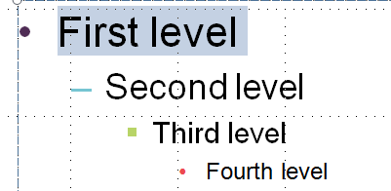 |  |  |  | First level, bullet: 28 pt, Dark Purple, Accent 1  Second level, en dash: 24 pt, Aqua Accent 2  Third level, square: 20 pt, Lime, Accent 3  Fourth level, bullet: 16 pt, Red, Accent 5
Check Font and Size (where possible, follow these standards)
Text (not bullets): 28 pt, Arial (body), black
In tables: 18 pt, Arial (body), black
References: 10 pt, Arial (body), black
Check Endnotes
Make sure there is a space between the text and endnotes
Make sure all asterisks are NOT superscript
 | Check Coloring of Tables, Charts/Graphs, Smart Art
 | Check that tables are similar to sample: |  | 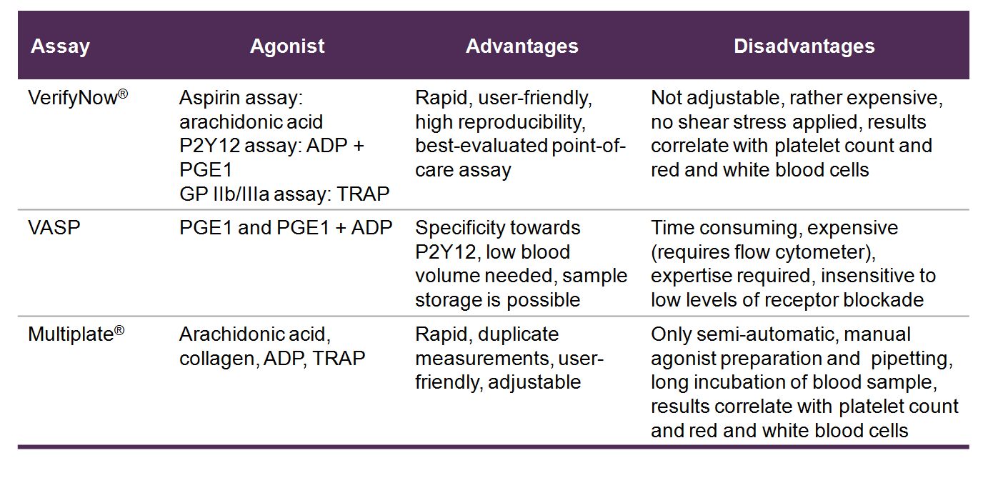
 | Check Bar Graphs Colors
 | 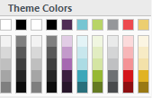 | Primary Color:  Dark Purple, Accent 1  Primary should be used for AZ Brand |  | Secondary Color:  Red, Accent 5  Secondary can be used for major competitor |  | Tertiary Color:  Aqua, Accent 2 | Quarternary Color:  Lime, Accent 3
 | Check Line Charts Colors
 |  | Primary Color:  Dark Purple, Accent 1 |  | Secondary Color:  Red, Accent 5  Darker 25% |  | Tertiary Color:  Aqua, Accent 2  Darker 25% | Quarternary Color:  Lime, Accent 3  Darker 50%
Check text boxes for References and Abbreviations/Footnotes
- Delete ”CI = confidence interval” if found in Abbreviations text box.
- Abbreviations should only be defined once in the slide deck, on slide with first mention.
- “Definition” does not need to be in content; abbreviation only needs to be defined in Abbreviations text box.
- Delete spaces around equal marks; use equal marks instead of commas.
- Insert a line break in long URLs (shift-Enter).
Check Slide Animation
- Advance Slide>On Mouse Click
Check to make sure “Speaker Notes Disclaimer” are at the bottom of Notes page:
- “Speaker notes are for internal use only and are not to be shown or disseminated outside of AstraZeneca.”
Change View and Look it Over One More Time
- Slide Show
  - Check all links
- Notes Page view
  - Make sure there is NOT >1 text box for notes
  - Adjust font size and text box size to make it fit on the page
- Slide Sorter
 | Compare the two decks side by side
 | Save latest converted version to Sharepoint (and check it in)
 | Email other editor that it has been QC’d
 | Notes:

